PHP – HTML, CSS, SQLite

Laravel Assignment

MODULO-02

HTML, CSS, SQL

**Submitted To:-**

**Rajesh Nagar Sir**

**Submitted By:-**

**Ankita Sahu**

MODULE – 2 HTML, CSS, SQL

**Exercise 1: Try To Create User Details Form.**

Code:-

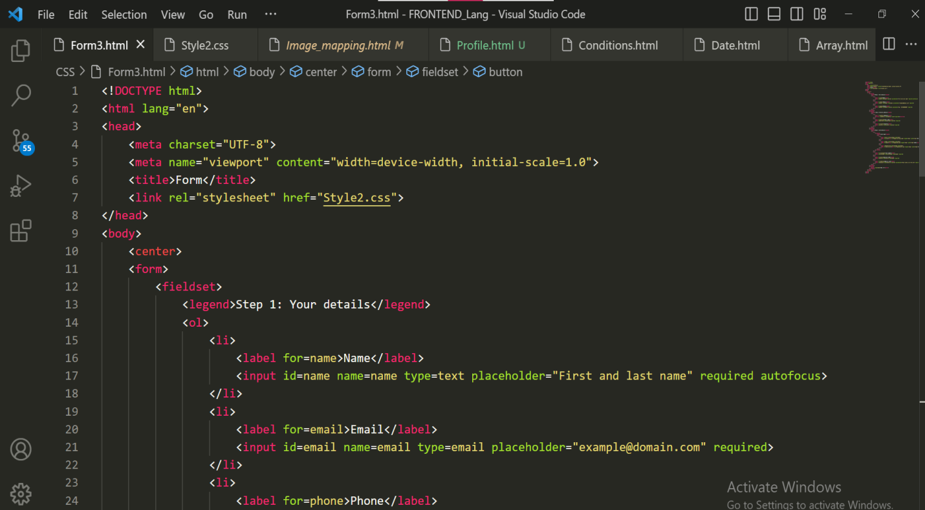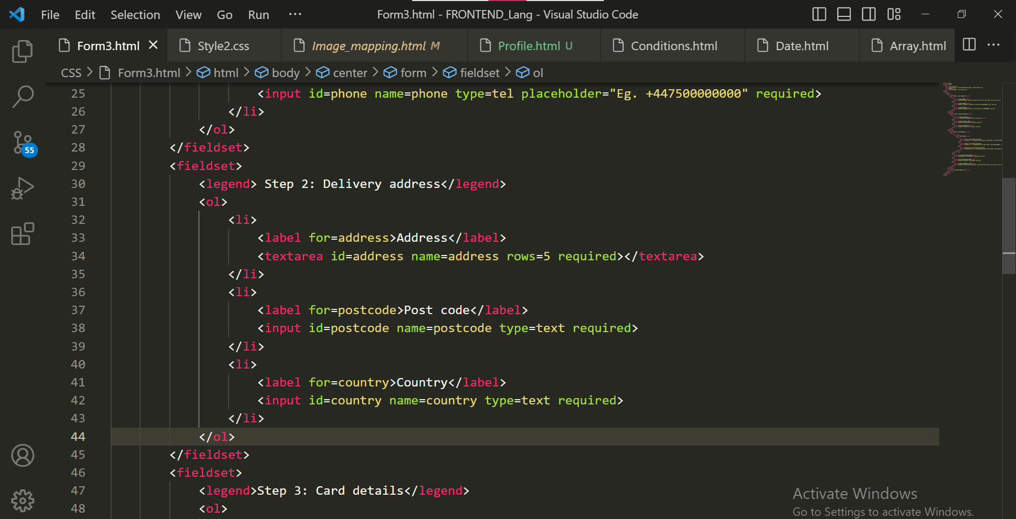

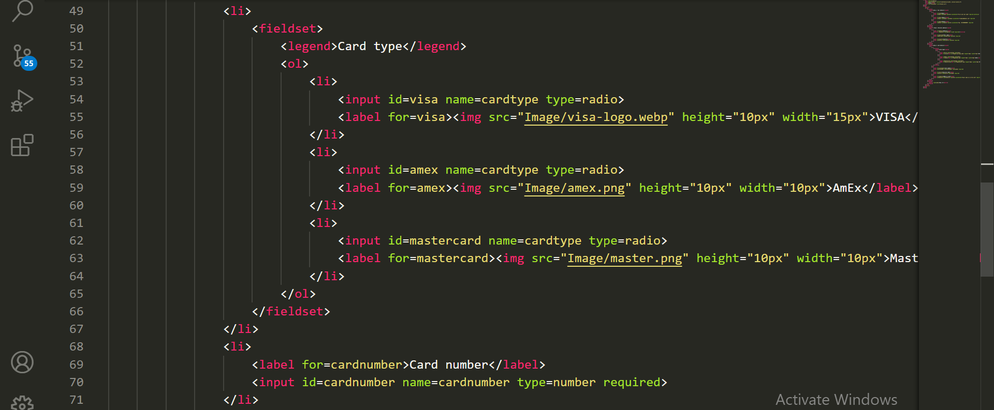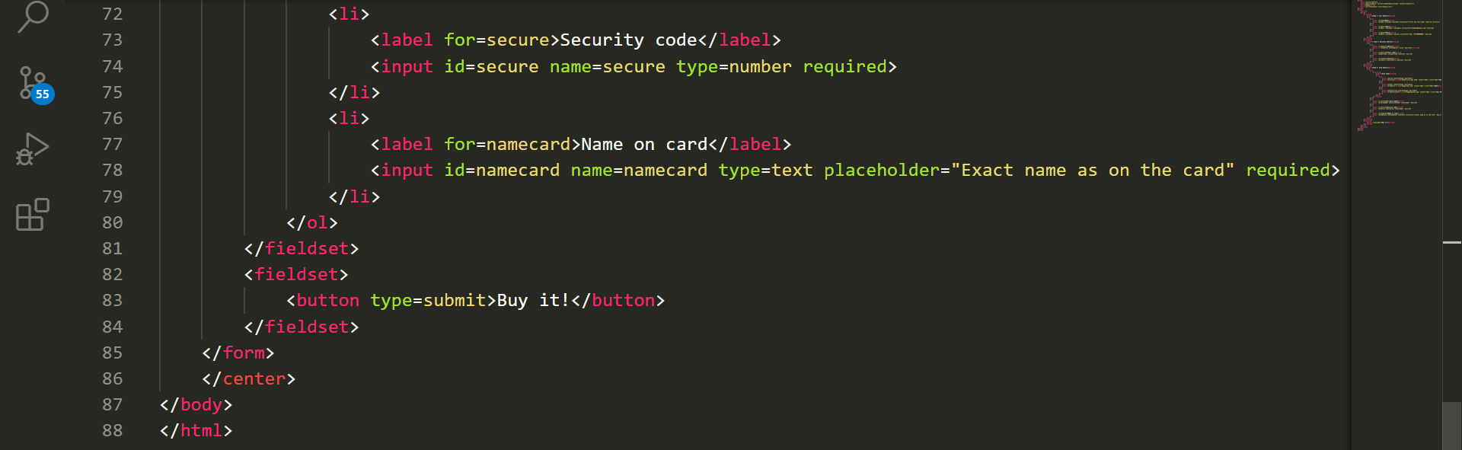

Style:-

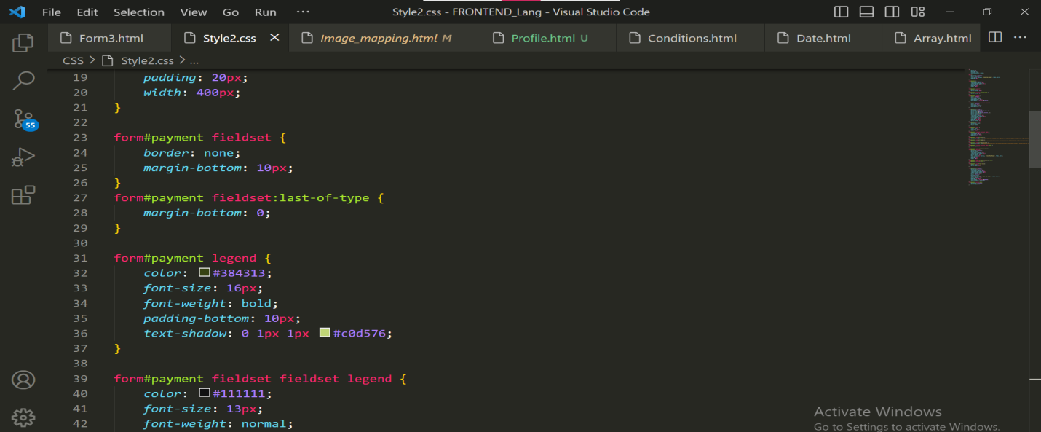

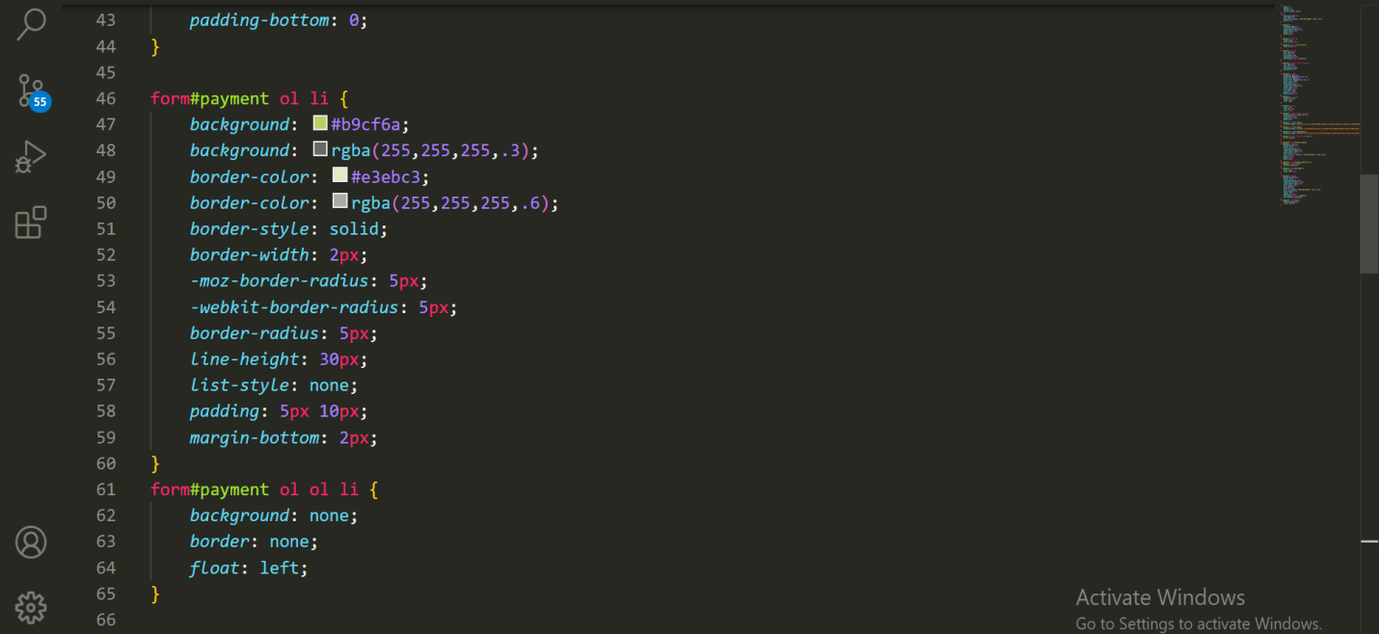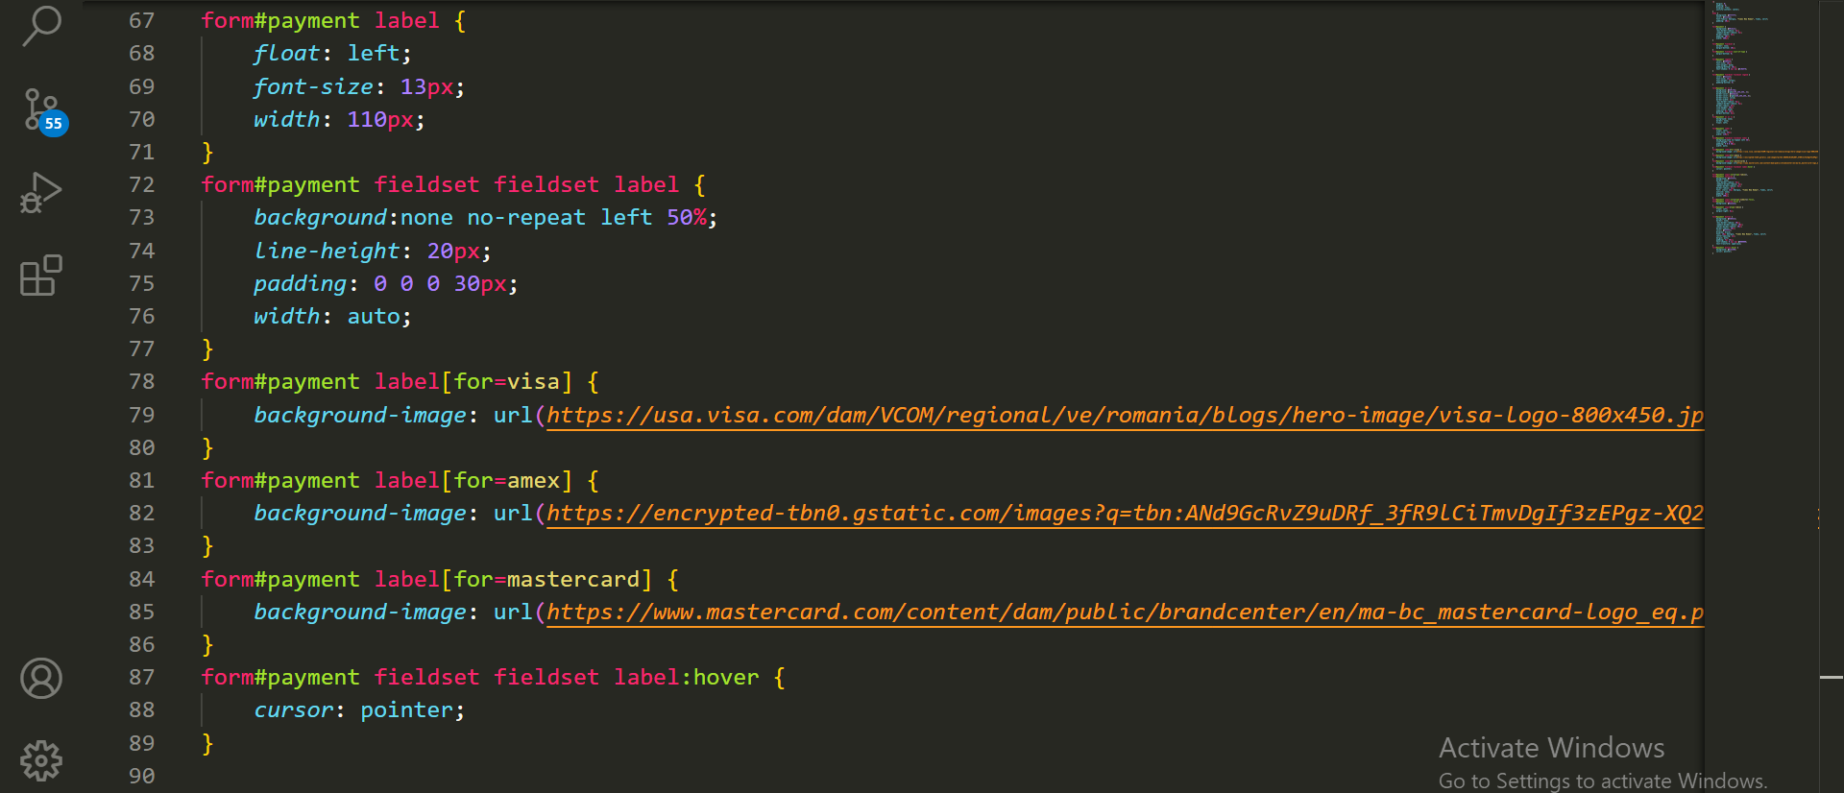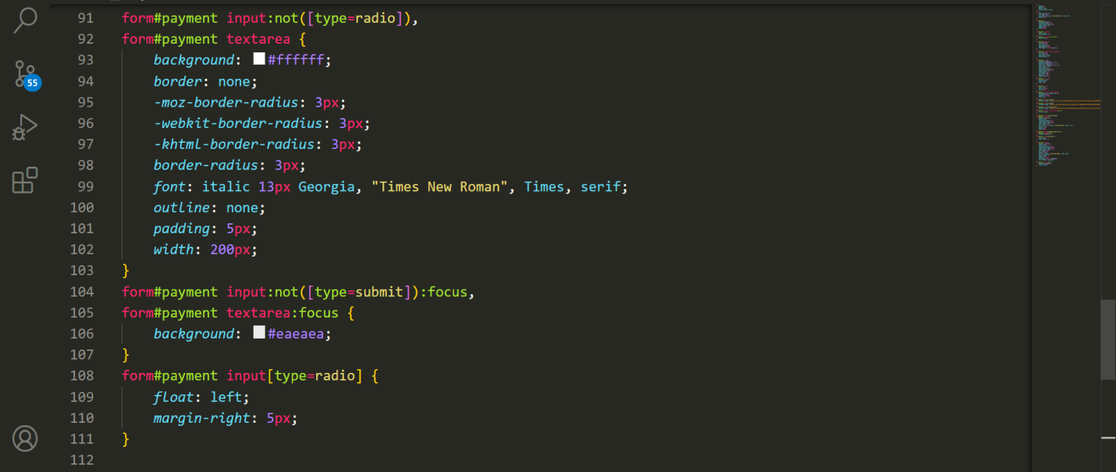

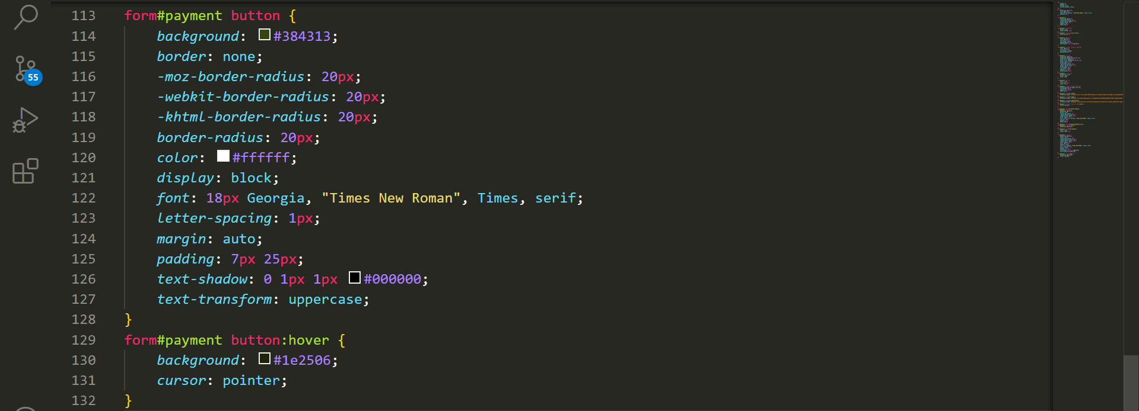

Output:-

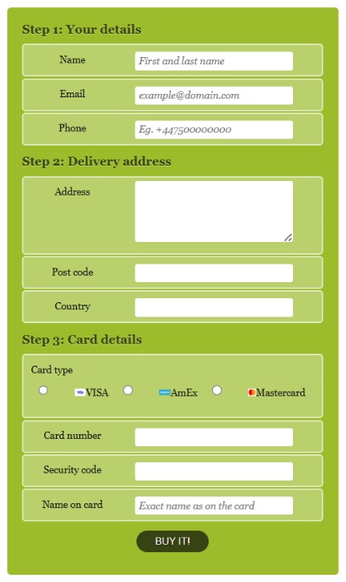

**BOOTSRAP**

**Exercise 1: Create manage Profile:**

Code:-

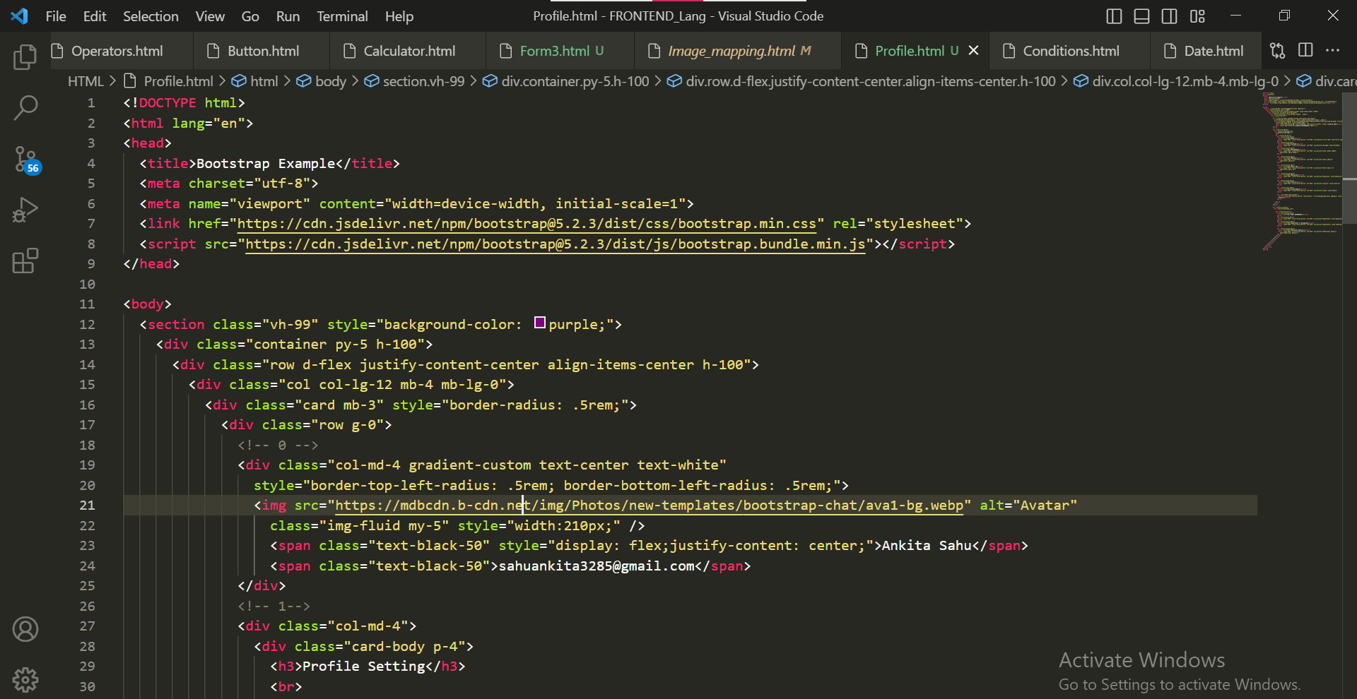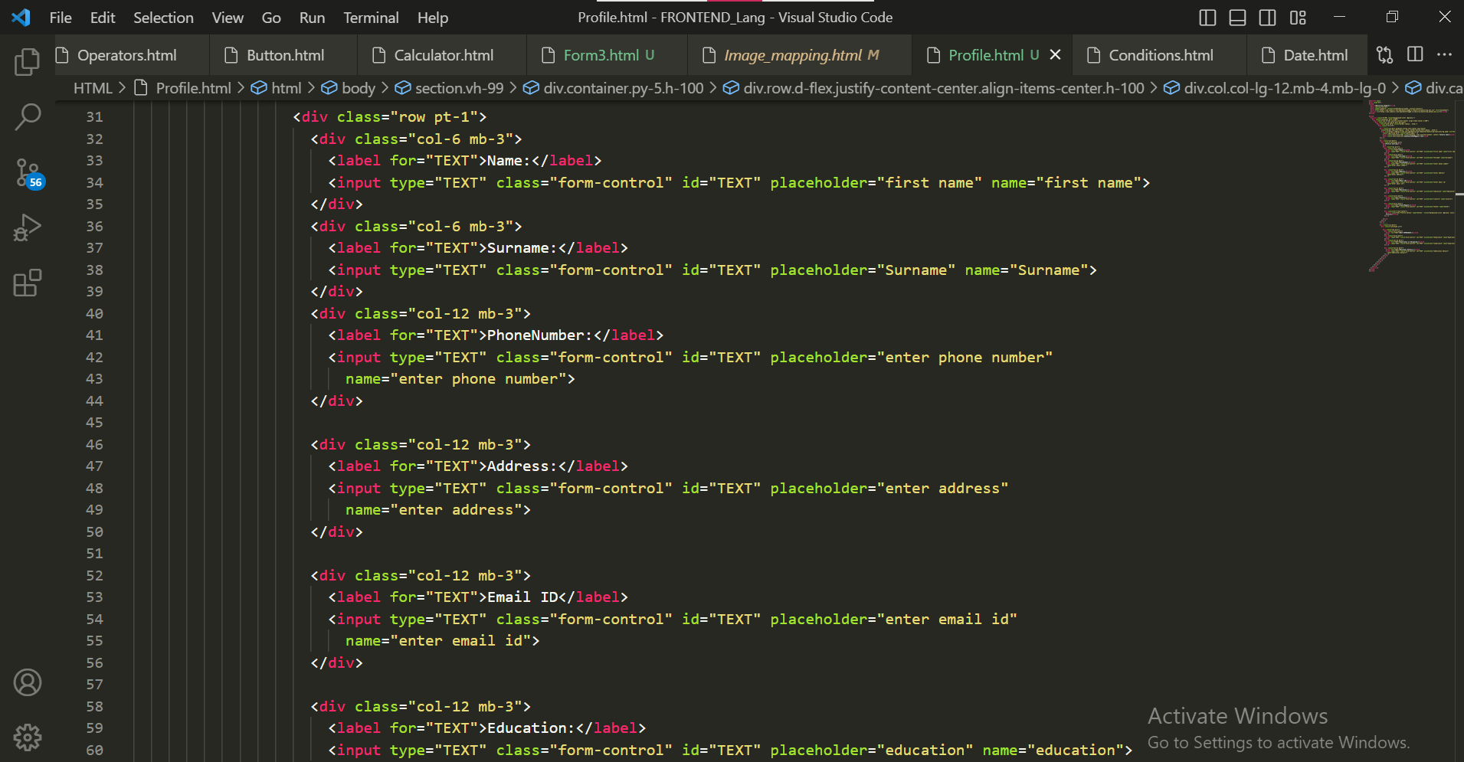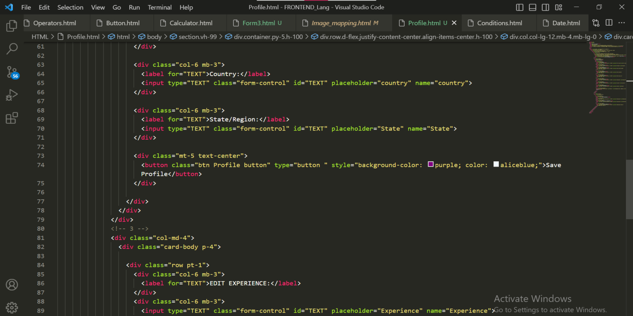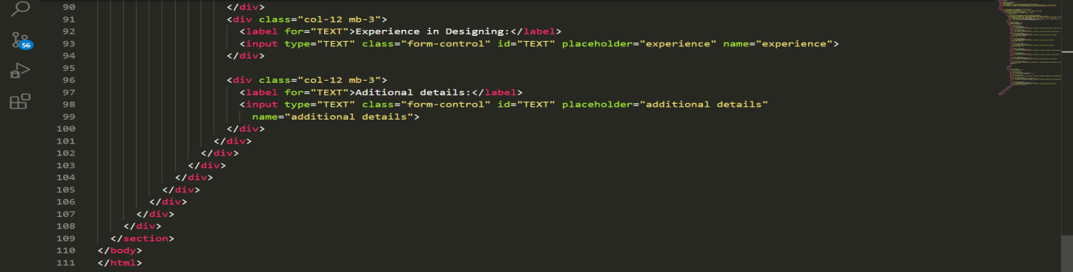

Output:-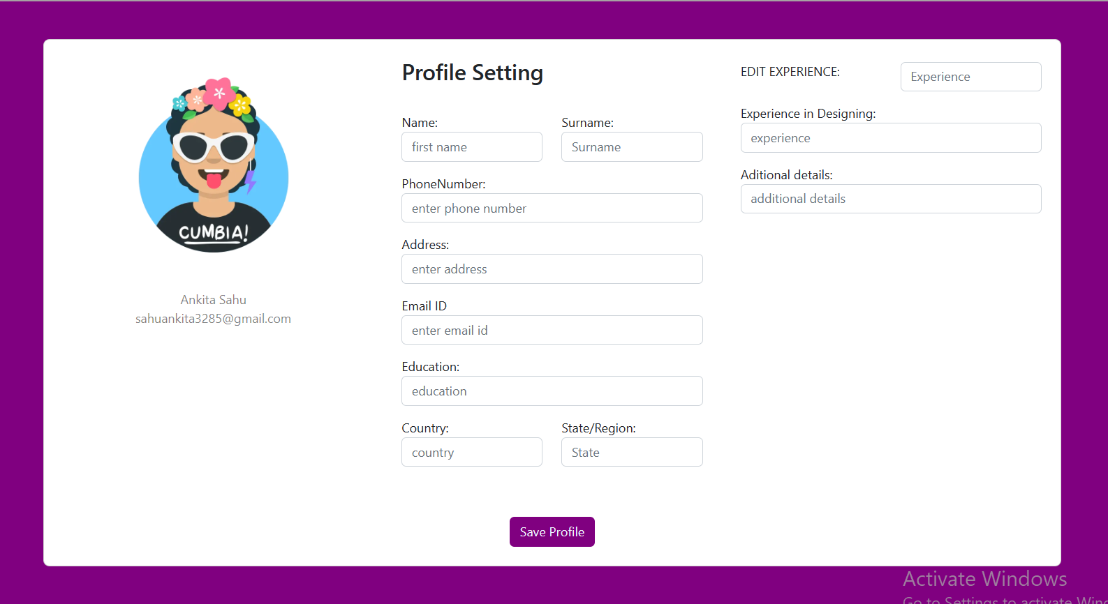

**Exercise 2: Create Product listing Page:**

Code:-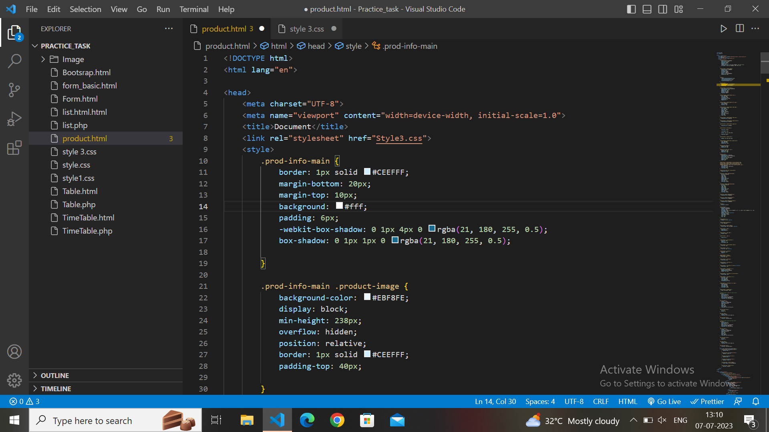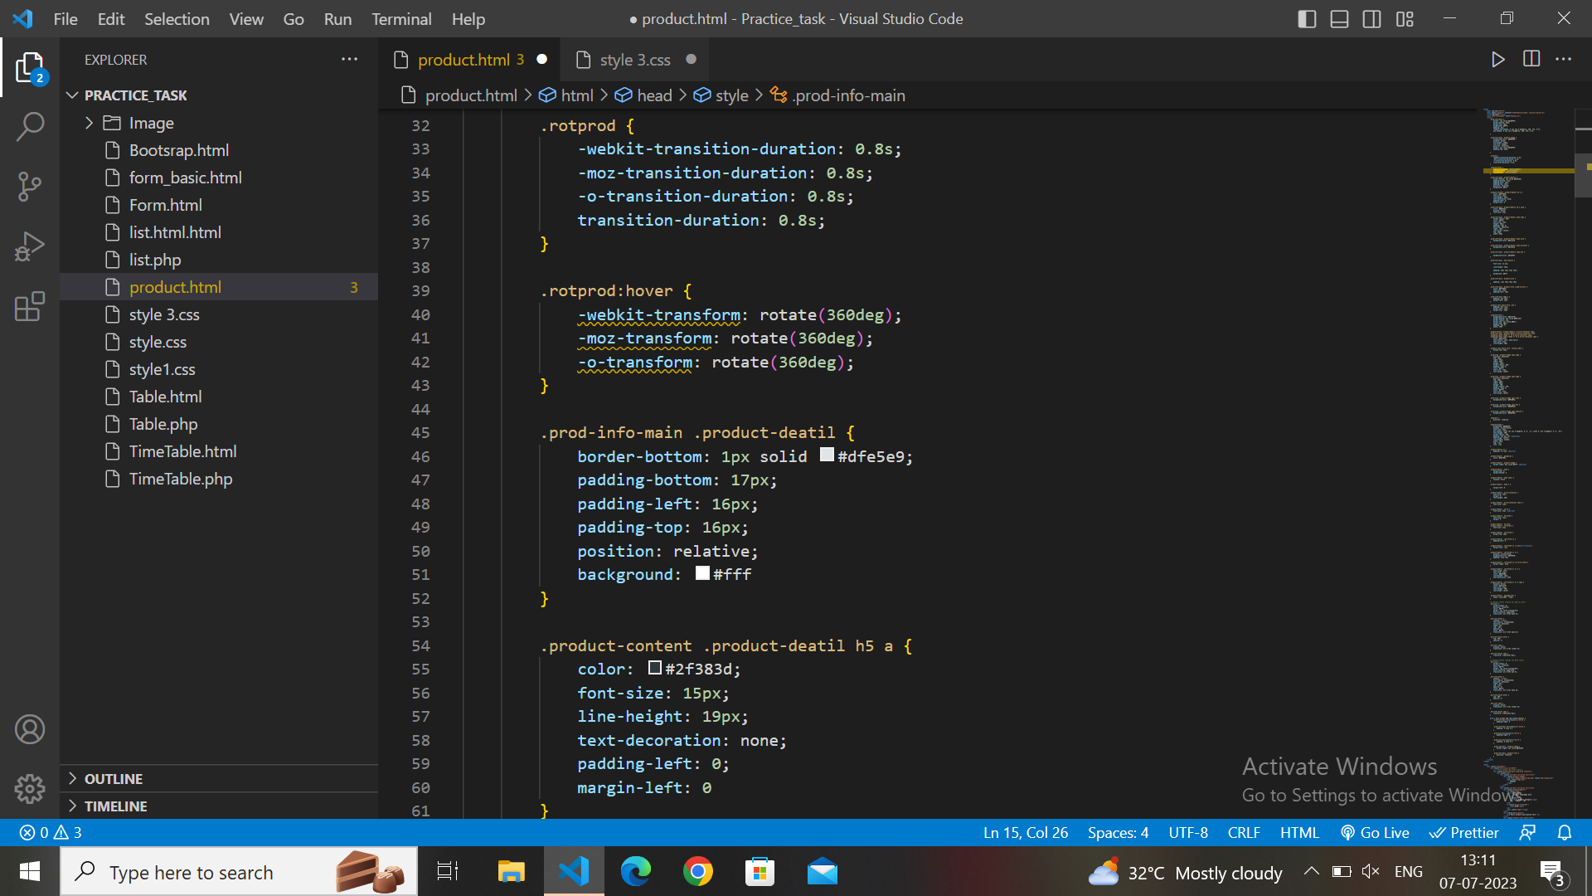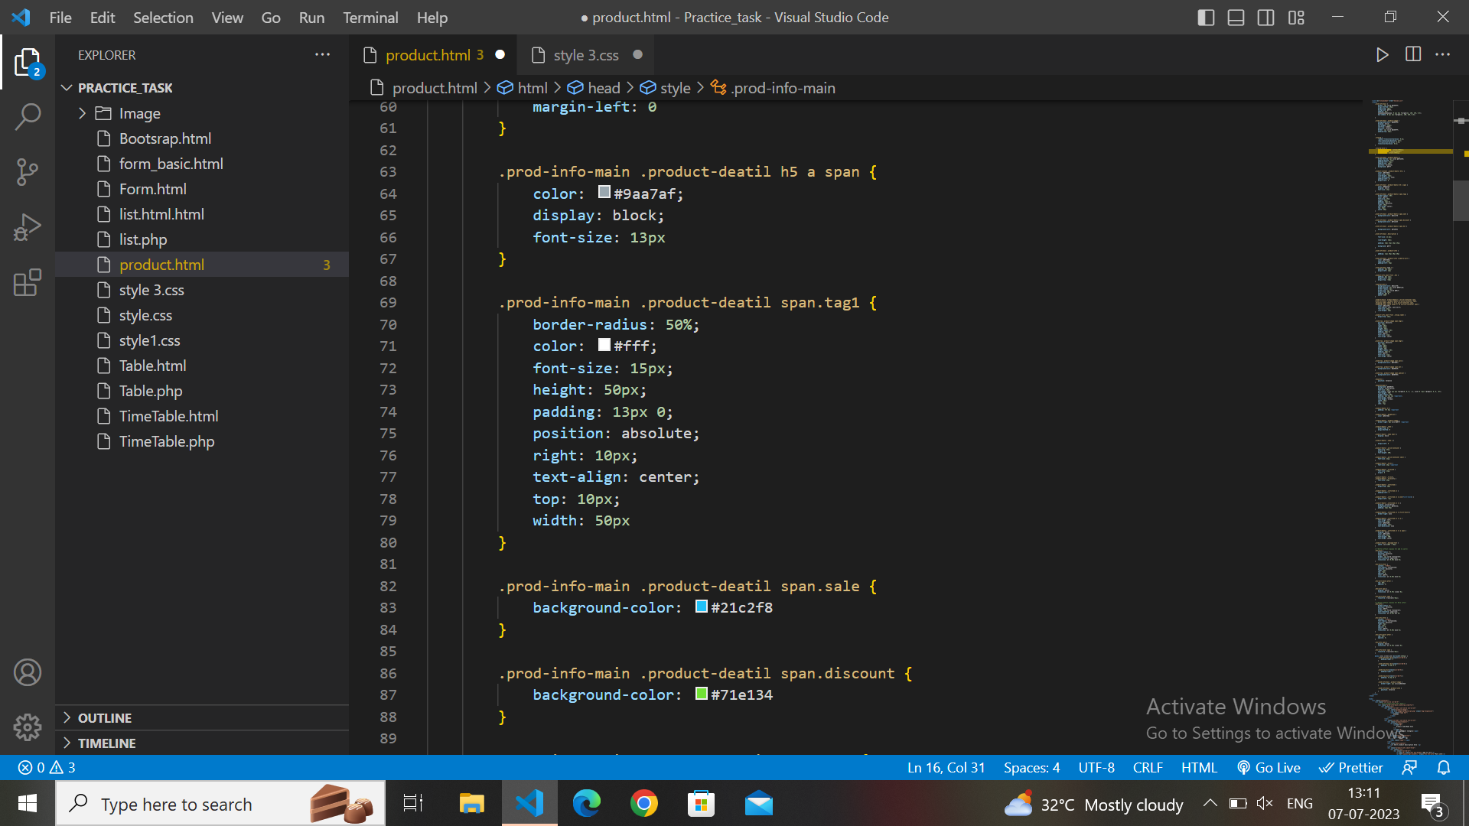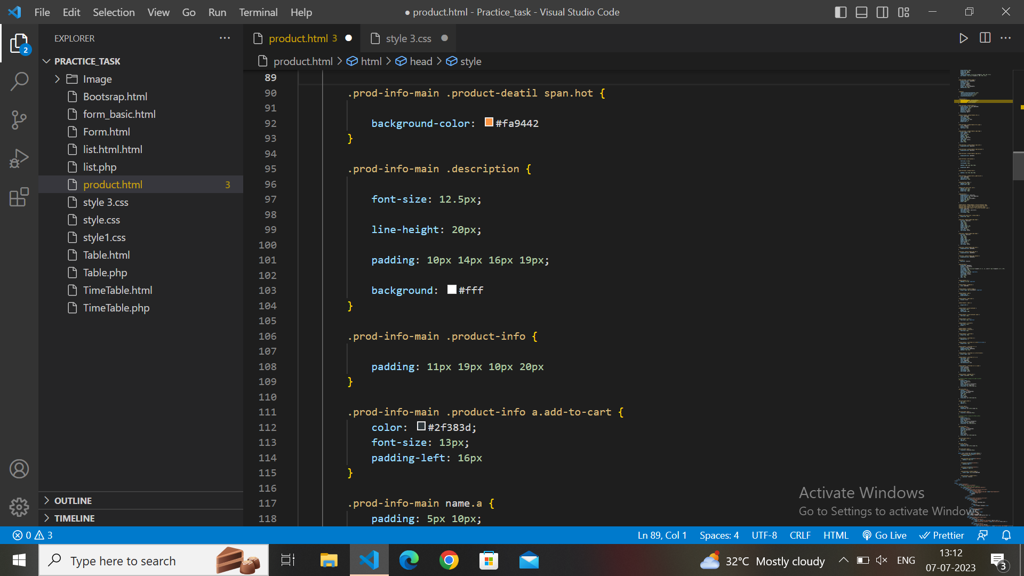

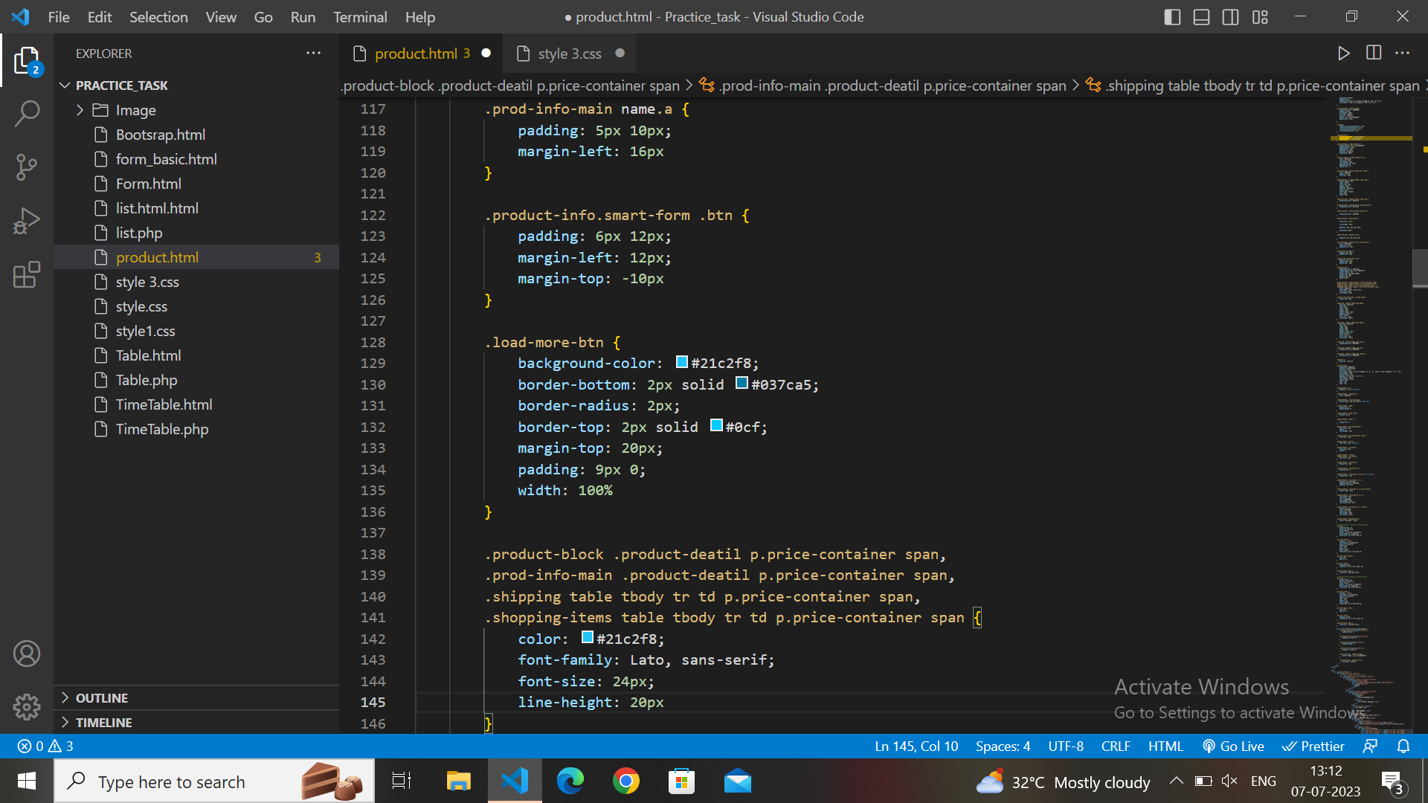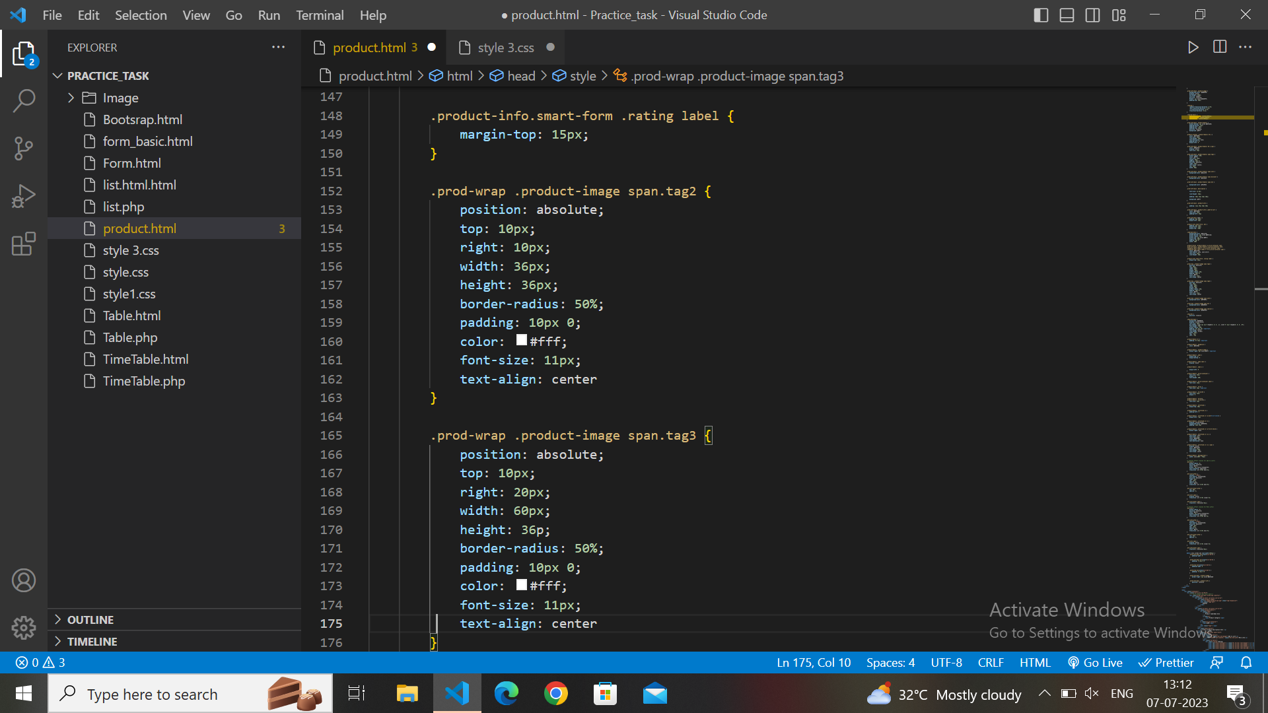

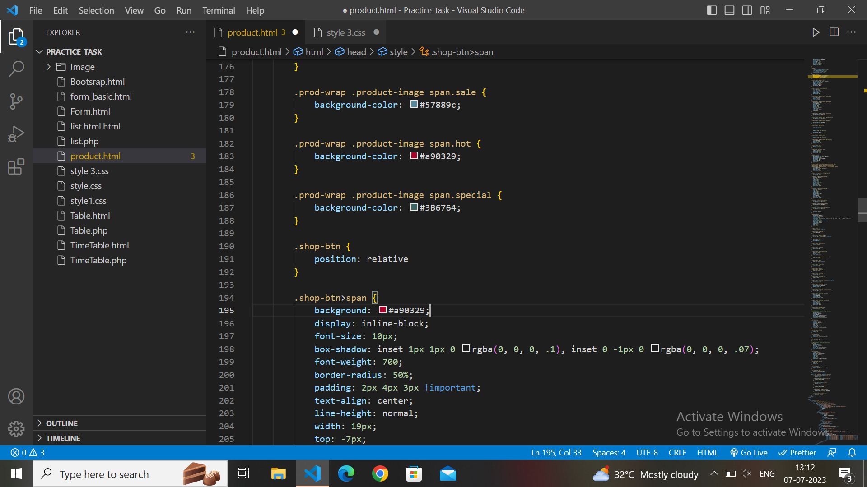

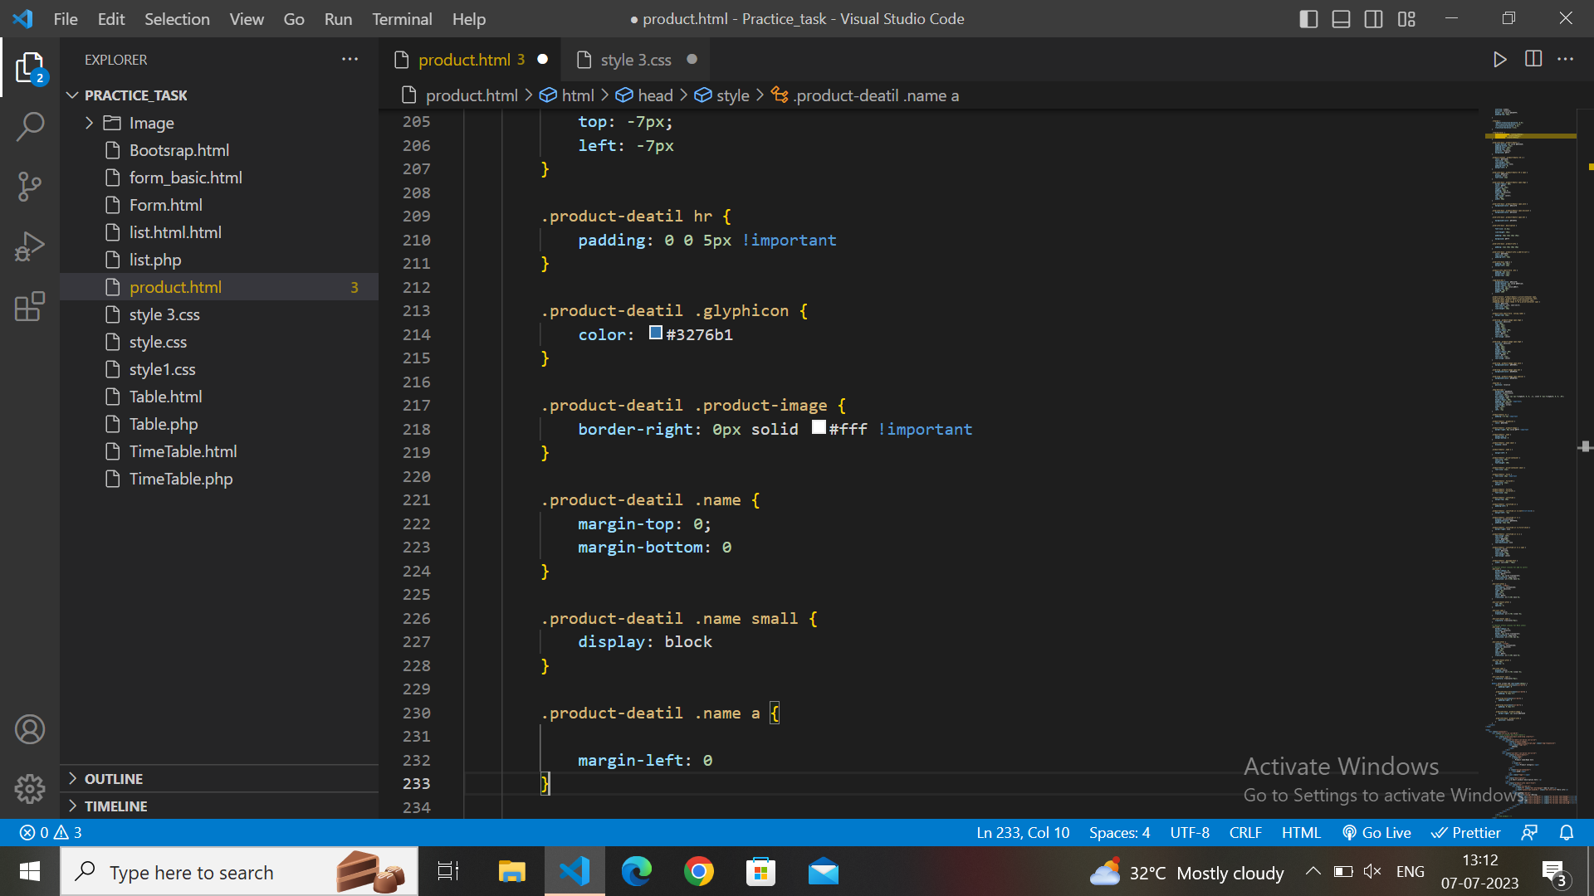

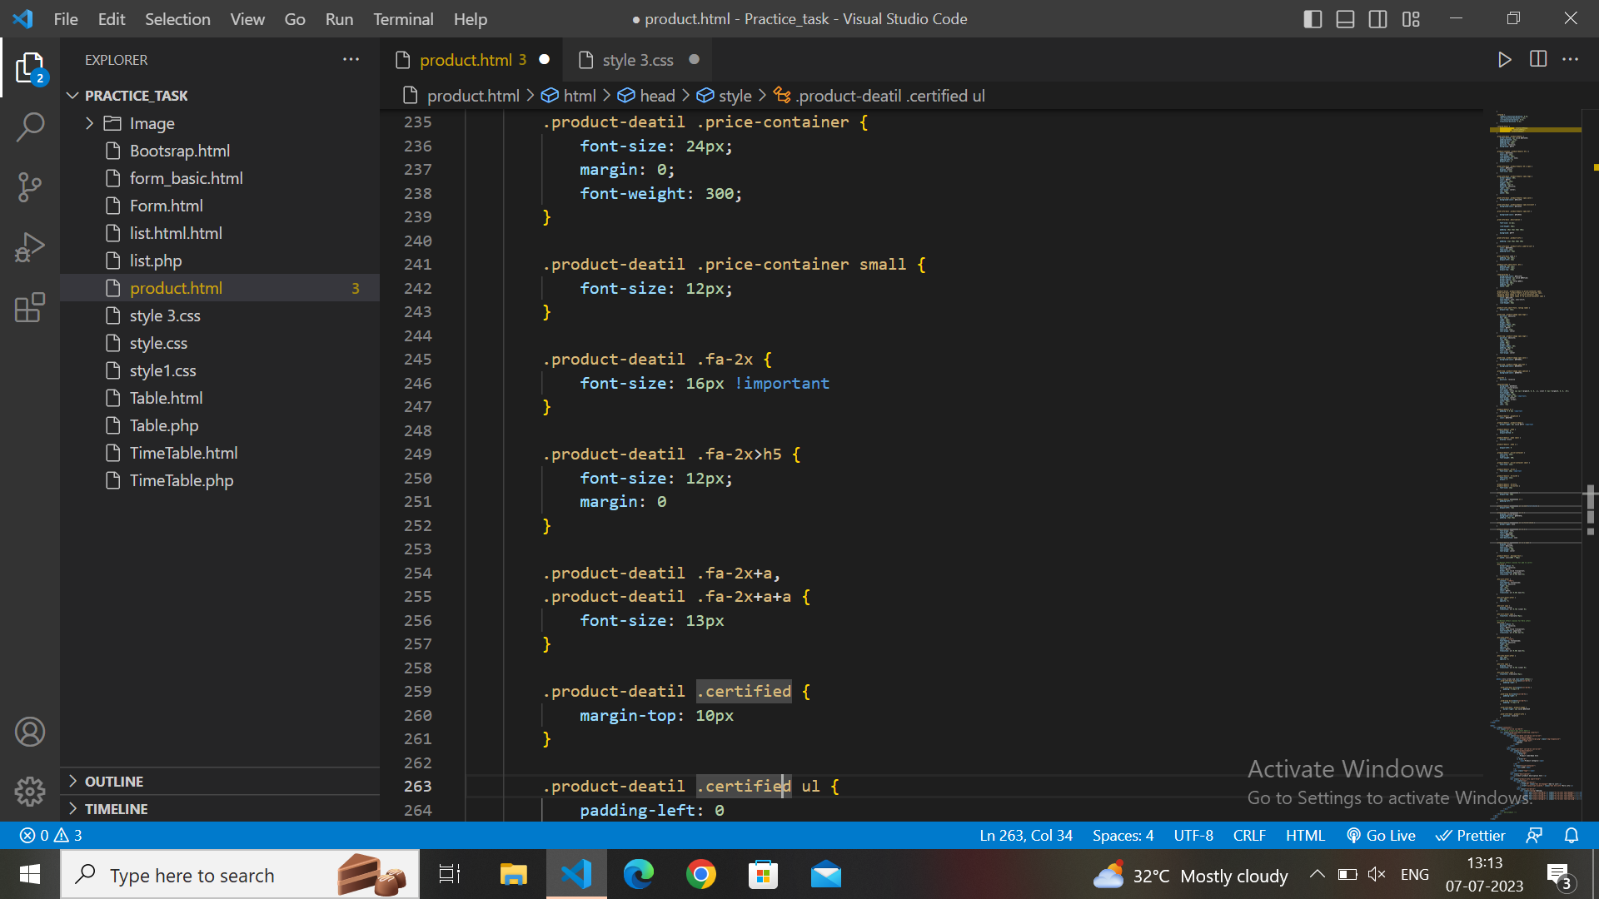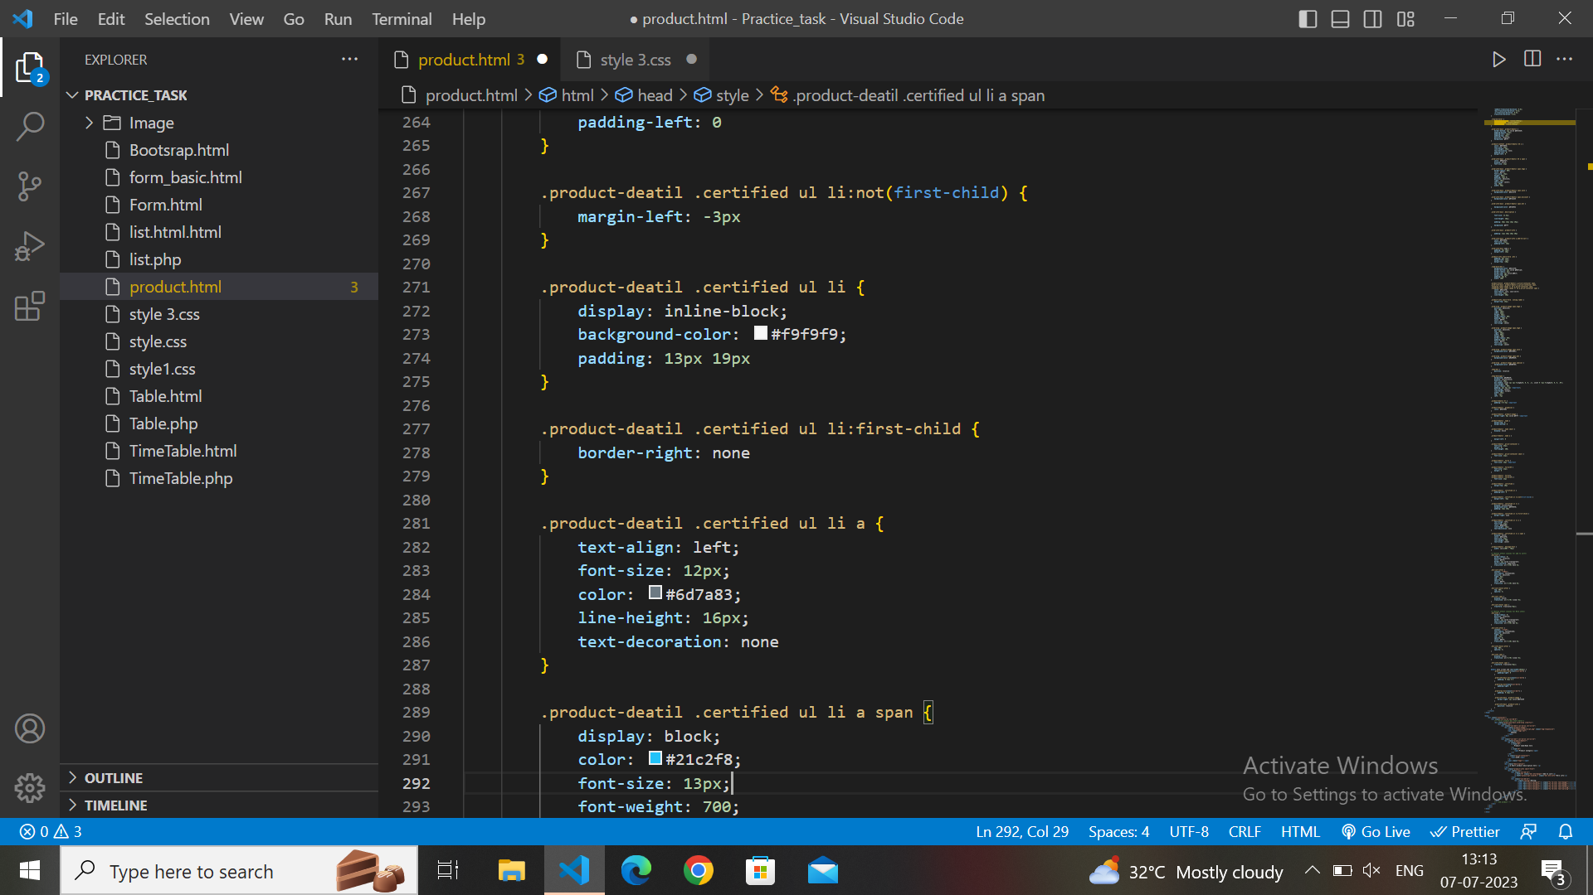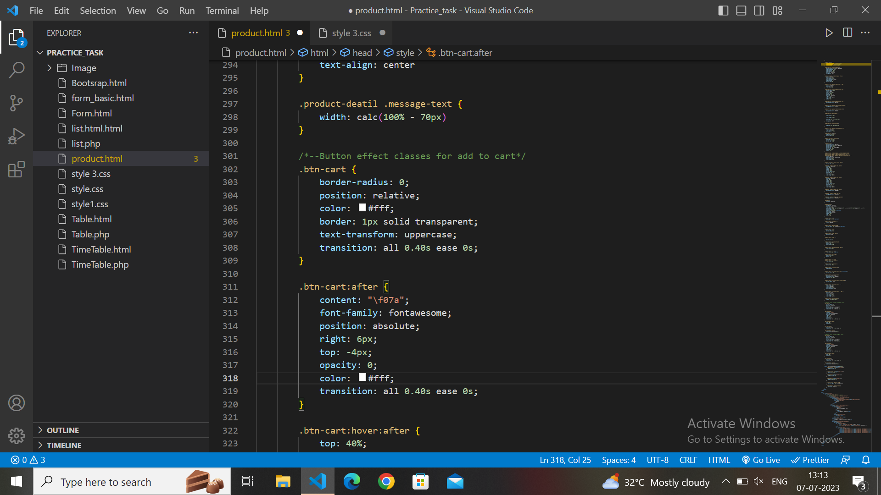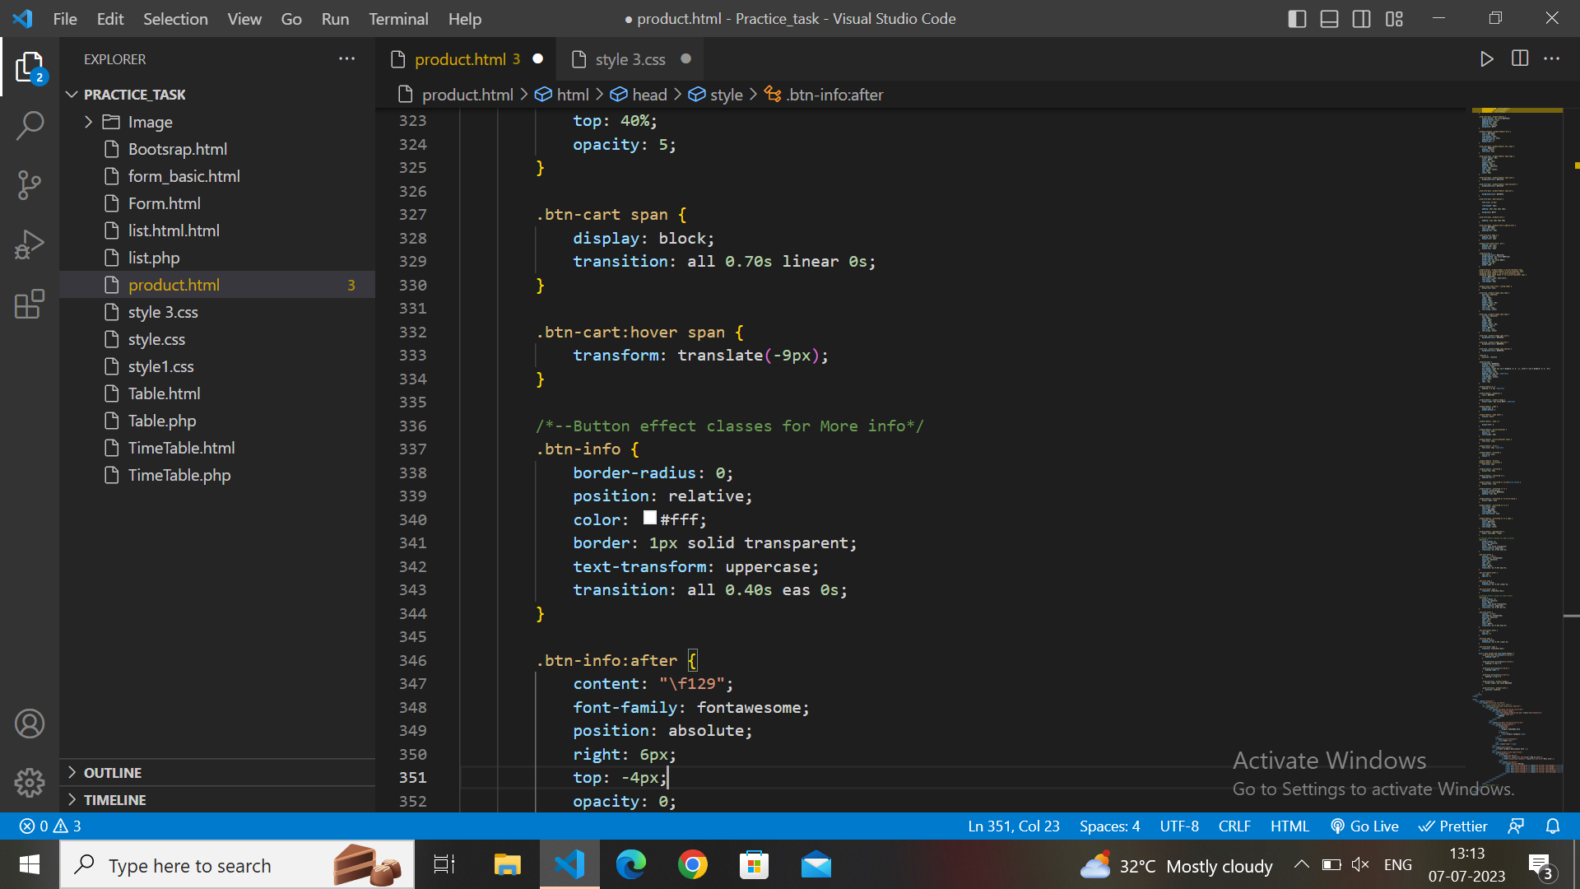

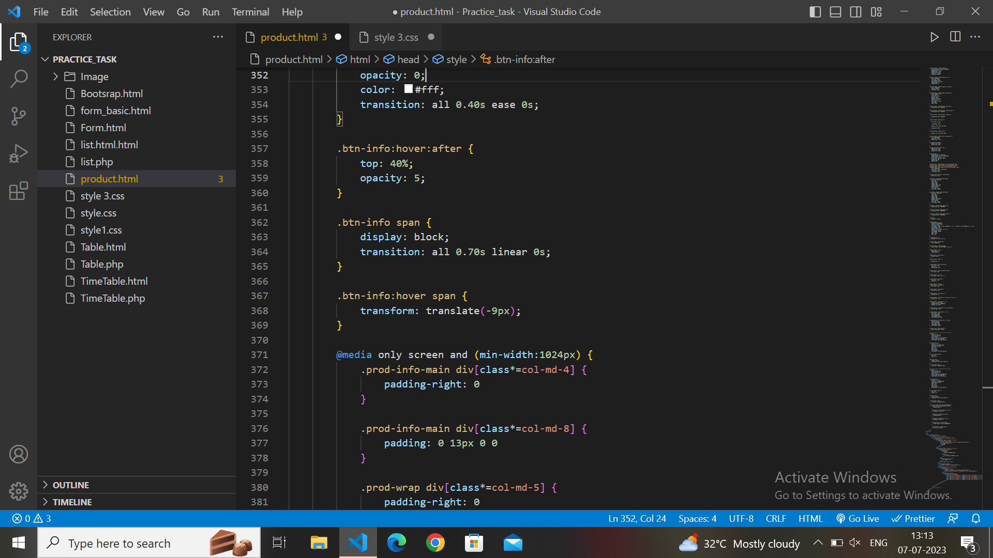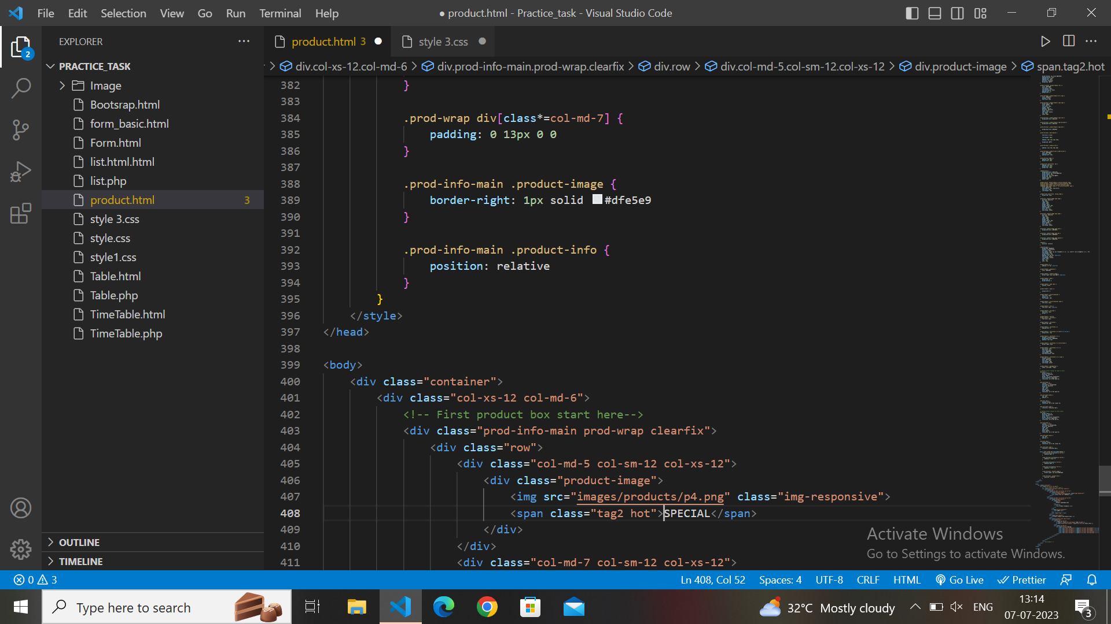

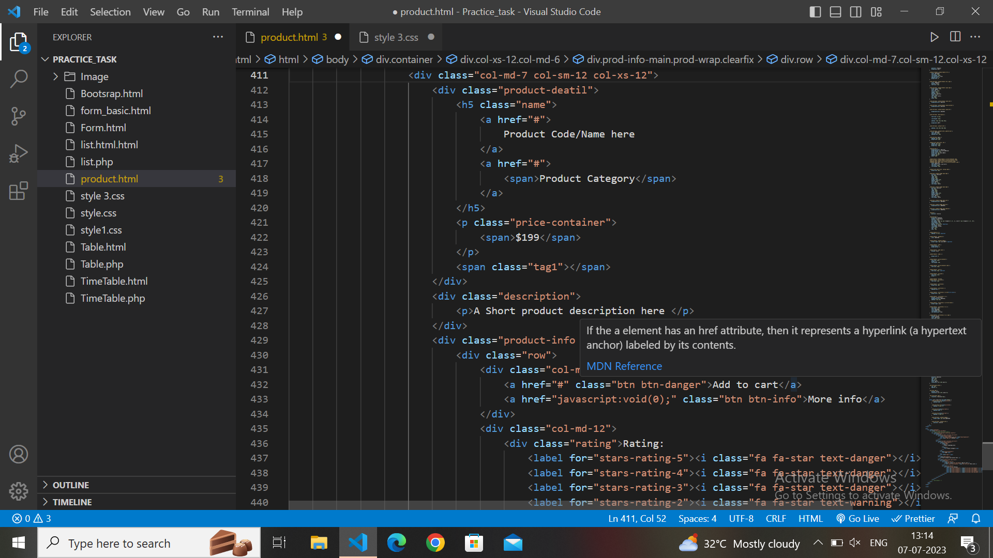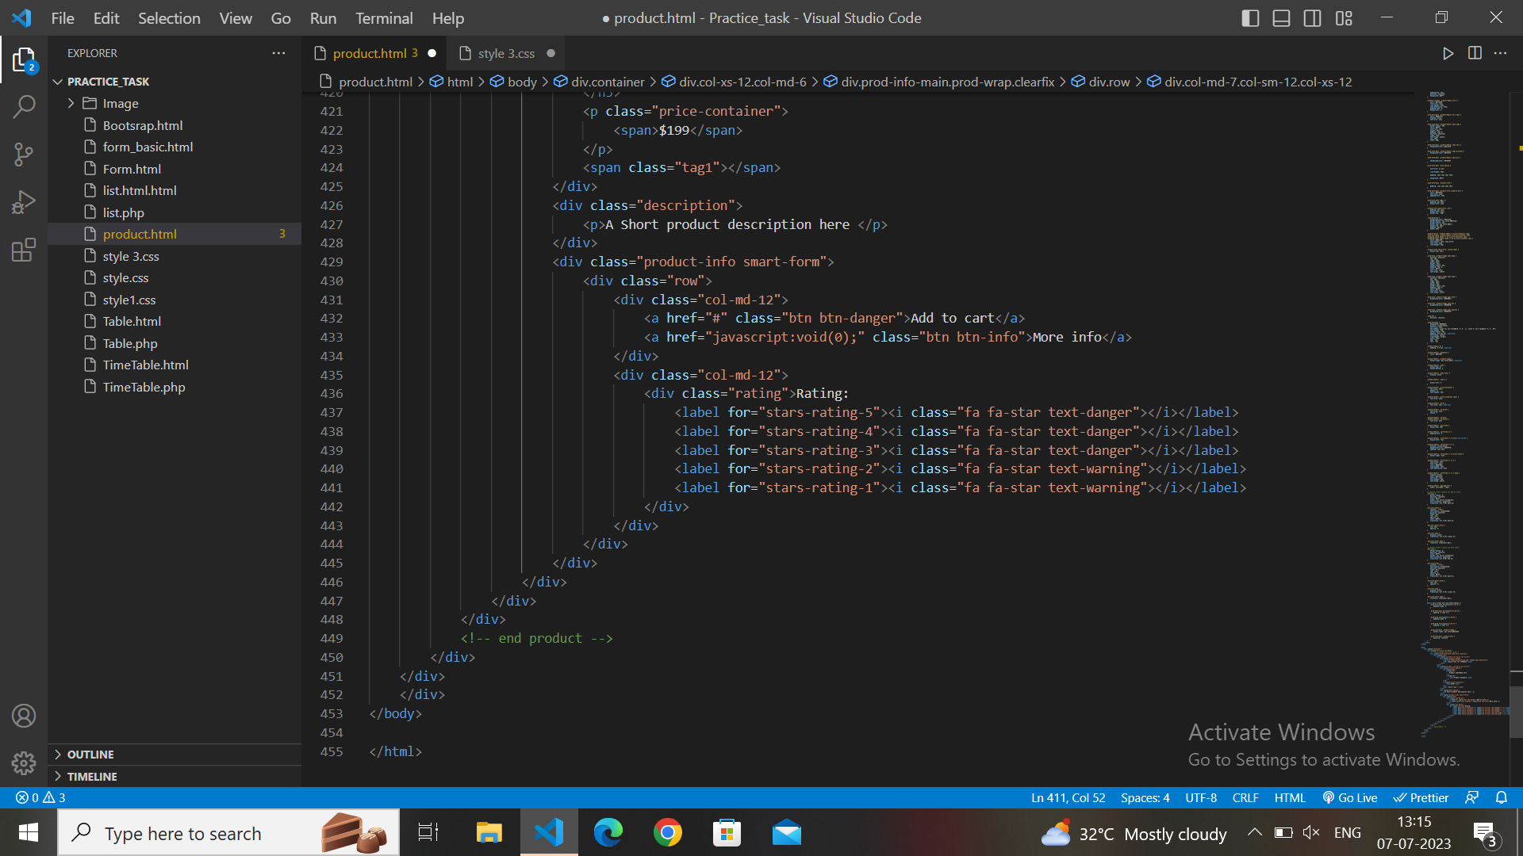

OutPut**:-**

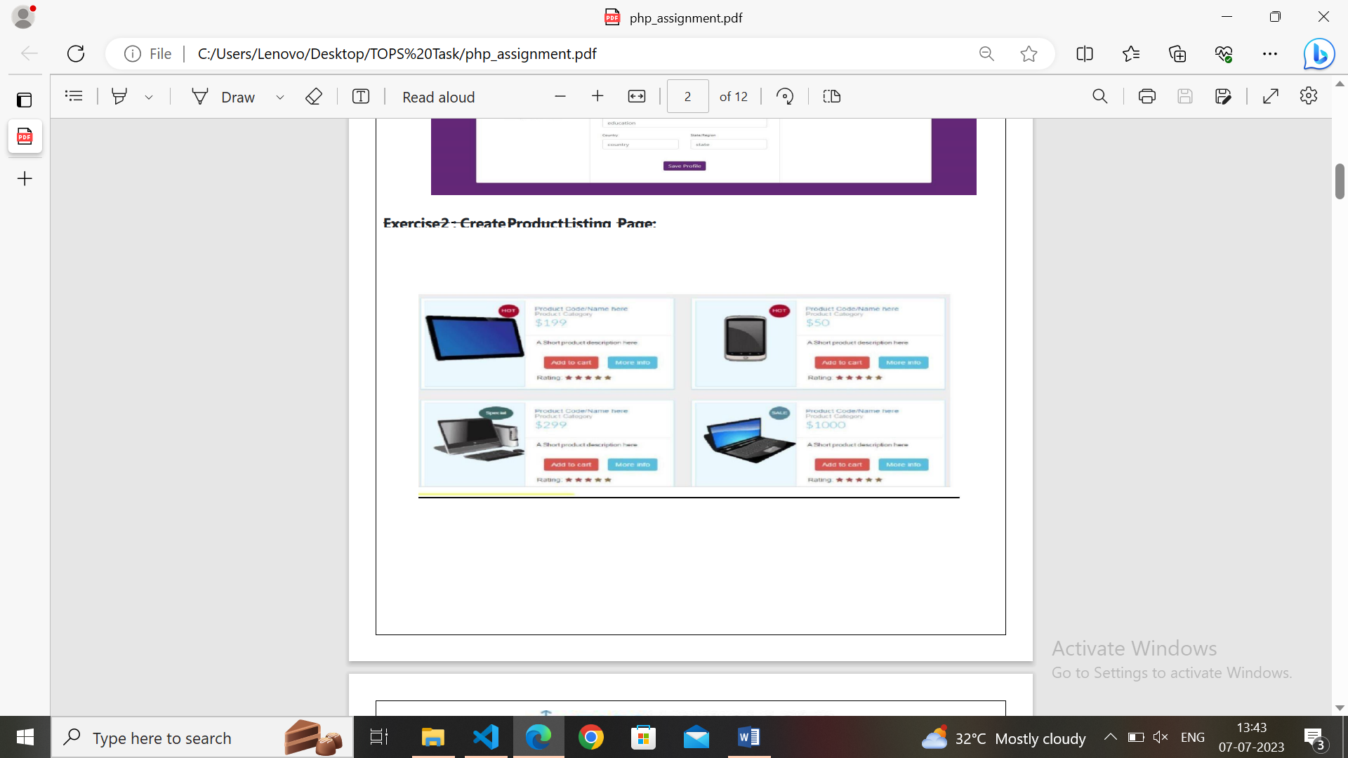

**Topic – SQL**

**Task-1**

**TABLE: - Employee**

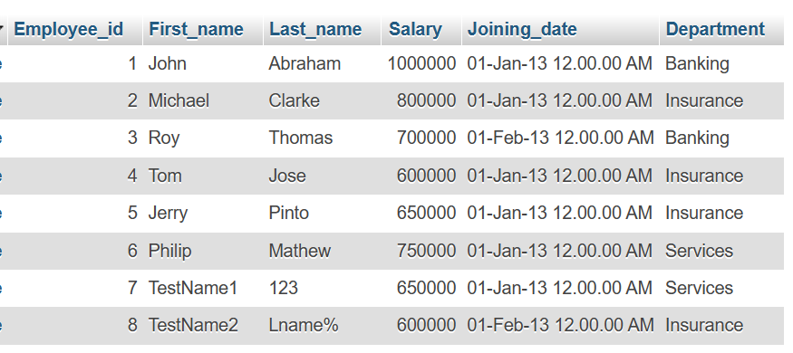

**TABLE: - Incentives**

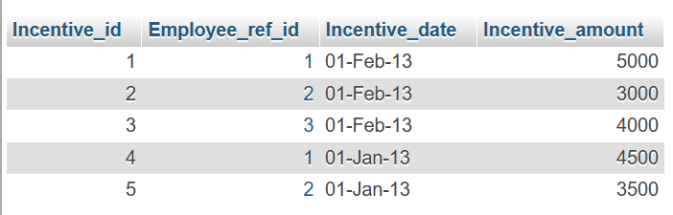

**a) Get First_Name from employee table using alias name “Employee Name”.**

**Query:-**

SELECT First_name as "Employe Name" FROM employee ;

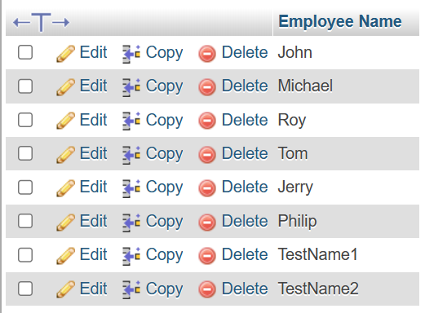

**b) Get FIRST_NAME, Joining year, Joining Month and Joining Date from employee table.**

**Query:-**

SELECT First_name,Joining_date,Salary FROM employee;

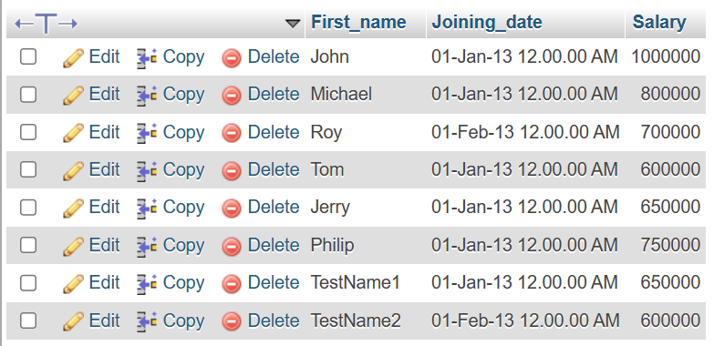

**c) Get all employee details from the employee table order by First Name Ascending And Salary descending?**

**Query:-**

SELECT * FROM employee ORDER BY First_name ASC, Salary DESC;

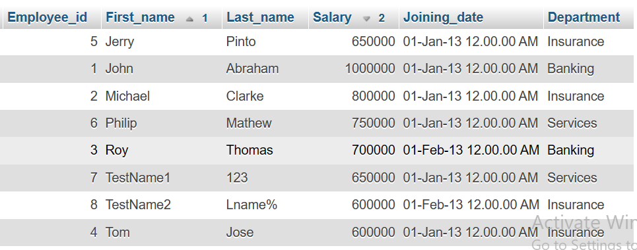

**d) Get employee details from employee table whose first name contains „o‟.**

**Query:-**

SELECT * FROM employee WHERE First_name LIKE ‘„o‟’;

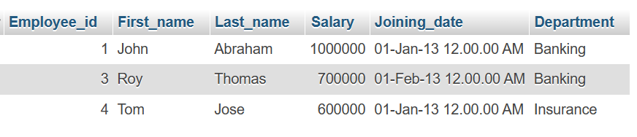

**e) Get employee details from employee table whose joining month is “January”.**

**Query:-**

Select * from employee where Month (Joining_date)="Jan";

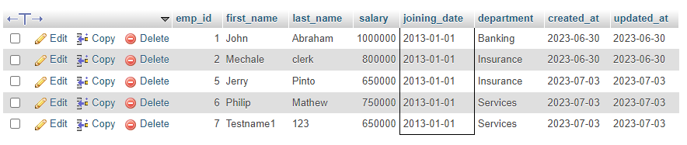

**f) Get department, total salary with respect to a department from employee table order By total salary descending.**

**Query:-**

Select Department, SUM (Salary) FROM employee GROUP BY Department ORDER BY DESC (Salary);

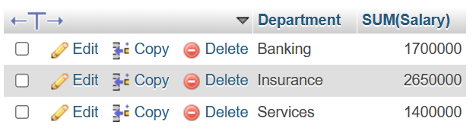

**g) Get department wise maximum salary from employee table order by salary Ascending .**

**Query:-**

Select max(Salary) as salary, Department from employee GROUP by Department ORDER BY MAX(Salary);

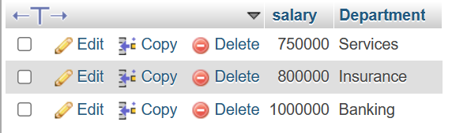

**h) Select first_name, incentive amount from employee and incentives table for those employees who have incentives and incentive amount greater than 3000.**

**Query:-**

SELECT First_name ,Incentive_amount FROM employee A INNER JOIN incentive B ON A.Employee_id=B.Employee_ref_id AND Incentive_amount >3000;

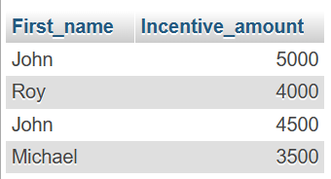

**i) Select 2nd Highest salary from employee table.**

**Query:-**

SELECT MAX (Salary) FROM employee WHERE Salary < (SELECT MAX(Salary)FROM employee);

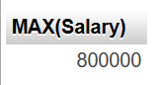

**j) Select first_name, incentive amount from employee and incentives table for all Employees who got incentives using left join.**

**Query:-**

SELECT First_name,NVL(Incentive_amount,0) FROM employee A LEFT JOIN incentive B ON A.Employee_id=B.Employee_ref_id;

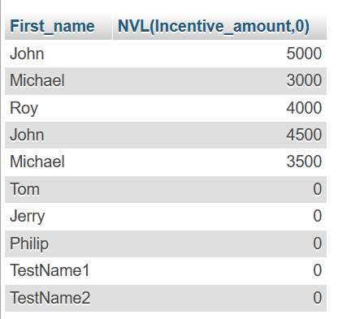

**k) Create View OF Employee table in which store first name ,last name and salary only.**

**Query:-**

SELECT Employee_id, First_name, Department FROM employee LEFT JOIN incentive ON incentive_id = incentive_id;

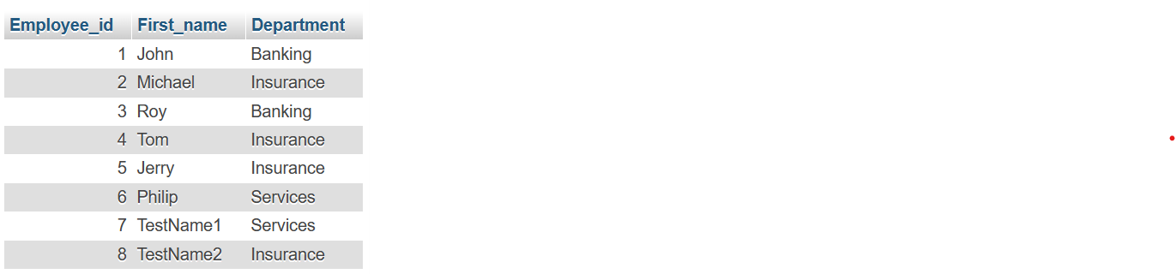

**l) Create Procedure to find out department wise highest salary.**

**Query:-**

CREATE procedure Department_sp as begin SELECT Department, max(Salary)Highest_salary from employee group by Department;

END exec department_sp;

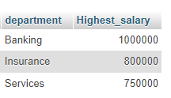

**m) Create After Insert trigger on Employee table which insert records in view table.**

**Query:-**

CREATE TRIGGER 'after insert' AFTER INSERT ON 'employee' FOR EACH ROW INSERT INTO Views (id,first_name,last_name,salary,joining_date,department) values (new.Employee_id,new.First_name,new.Last_name,new.Salary,new.Joining_date,new.Department);

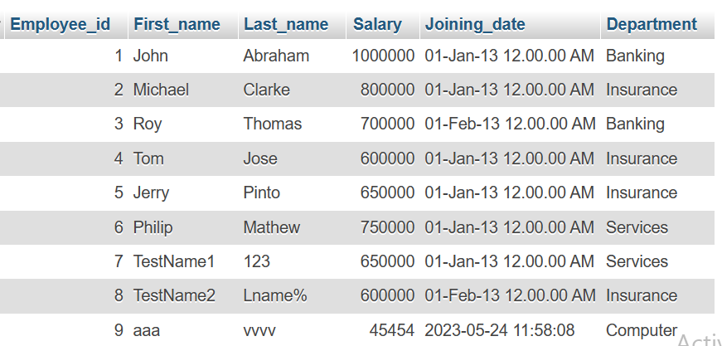

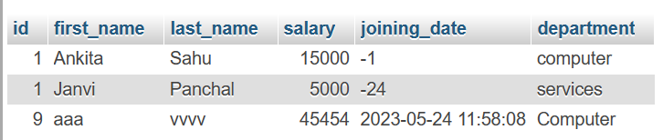

**Table Name : Views:-**

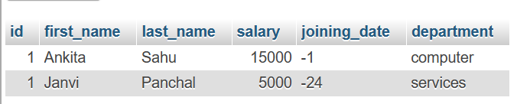

**Task-2**

**TABLE – SALES PERSON**

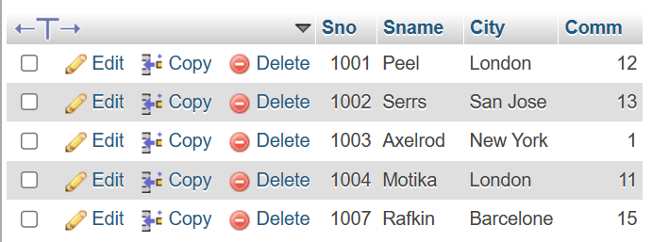

**TABLE – CUSTOMER**

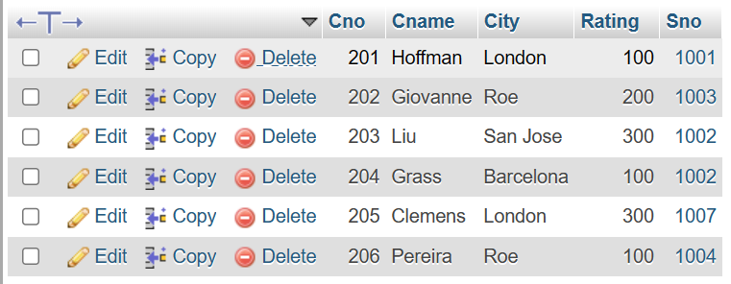

**TABLE – ORDER**

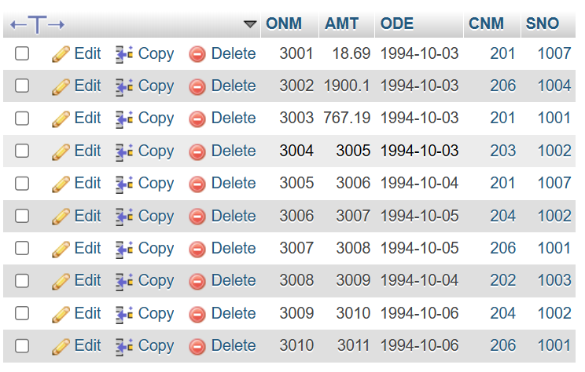

**a) All orders for more than $1000.**

**Query:-**

SELECT * FROM customer where RATING>100;

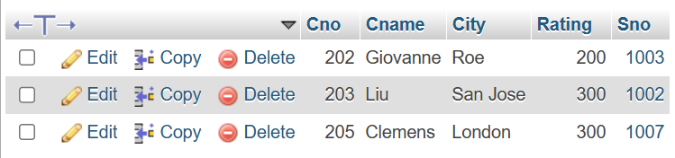

**b) Names and cities of all salespeople in London with commission above 0.10.**

**Query:-**

SELECT SNAME, CITY from salesperson WHERE CITY='London' AND COMM>10;

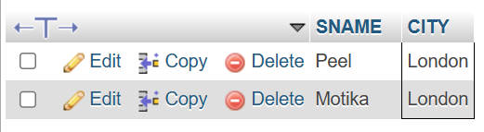

**c) All salespeople either in Barcelona or in London.**

**Query:-**

SELECT * from salesperson where CITY= 'barcelona' OR CITY= 'london';

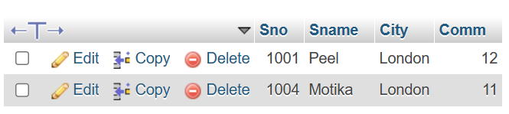

**d) All salespeople with commission between 0.10 and 0.12. (Boundary values should be excluded).**

**Query:-**

SELECT * from salesperson where COMM>10 and COMM<12;

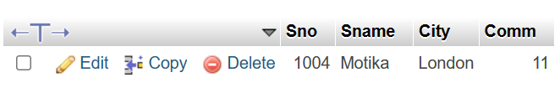

**e) All customers with NULL values in city column.**

**Query:-**

SELECT City FROM salesperson WHERE Sname = NULL;

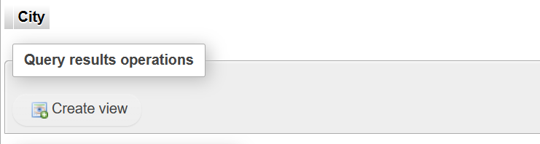

**f) All orders taken on Oct 3Rd and Oct 4th 1994.**

**Query:-**

Select * from begging where odate in (‘1994-10-03’,'1994-10-04’);

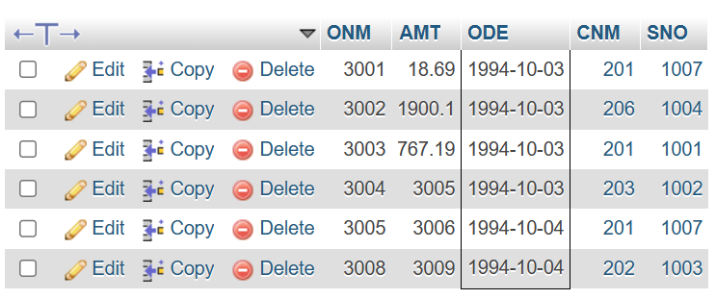

**g) All customers serviced by peel or Motika.**

**Query:-**

SELECT * FROM salesperson WHERE Sname="Peel" OR Sname="Motika";

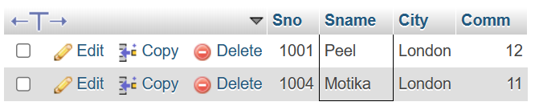

**h) All customers whose names begin with a letter from A to B .**

**Query:-**

SELECT Cname from customer where Cname LIKE 'A%' OR Cname LIKE 'B%' order by Cname;

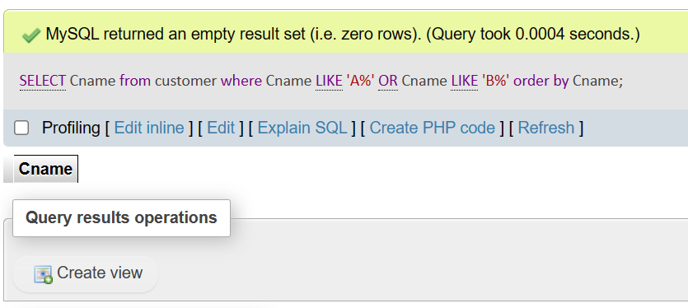

**i) All customers excluding those with rating <= 100 unless they are located in Rome.**

**Query:-**

SELECT * FROM CUSTOMER WHERE RATING>100 AND CITY !='ROM';

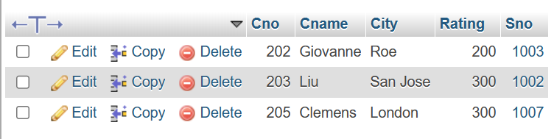

**j) All orders except those with 0 or NULL value in amt field.**

**Query:-**

Select ONM from begging where AMT ! = 0 or AMT is not null;

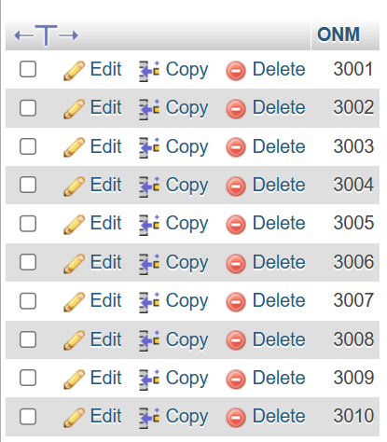

**k) Count the number of salespeople currently listing orders in the order table.**

**Query:-**

Select count(distinct SNO) from begging;

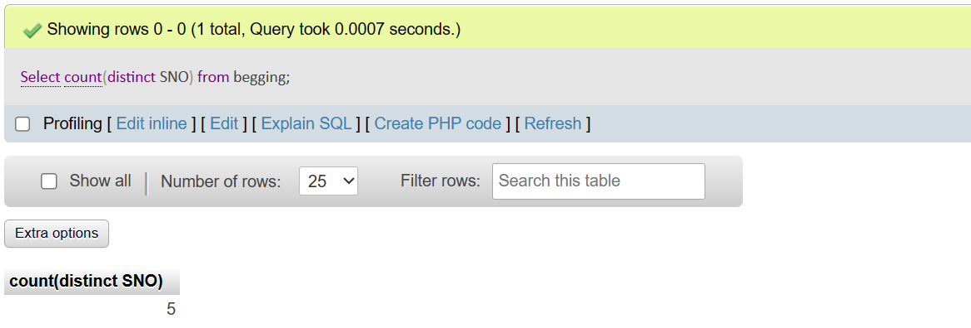

**XOOXOOXOOXOOXOOX**